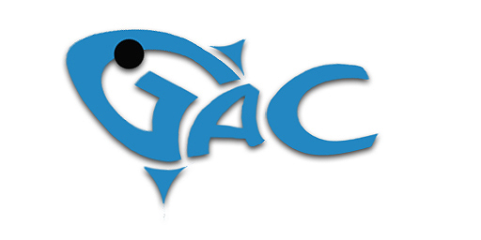GLAMORGAN ANGLERS CLUB LTD
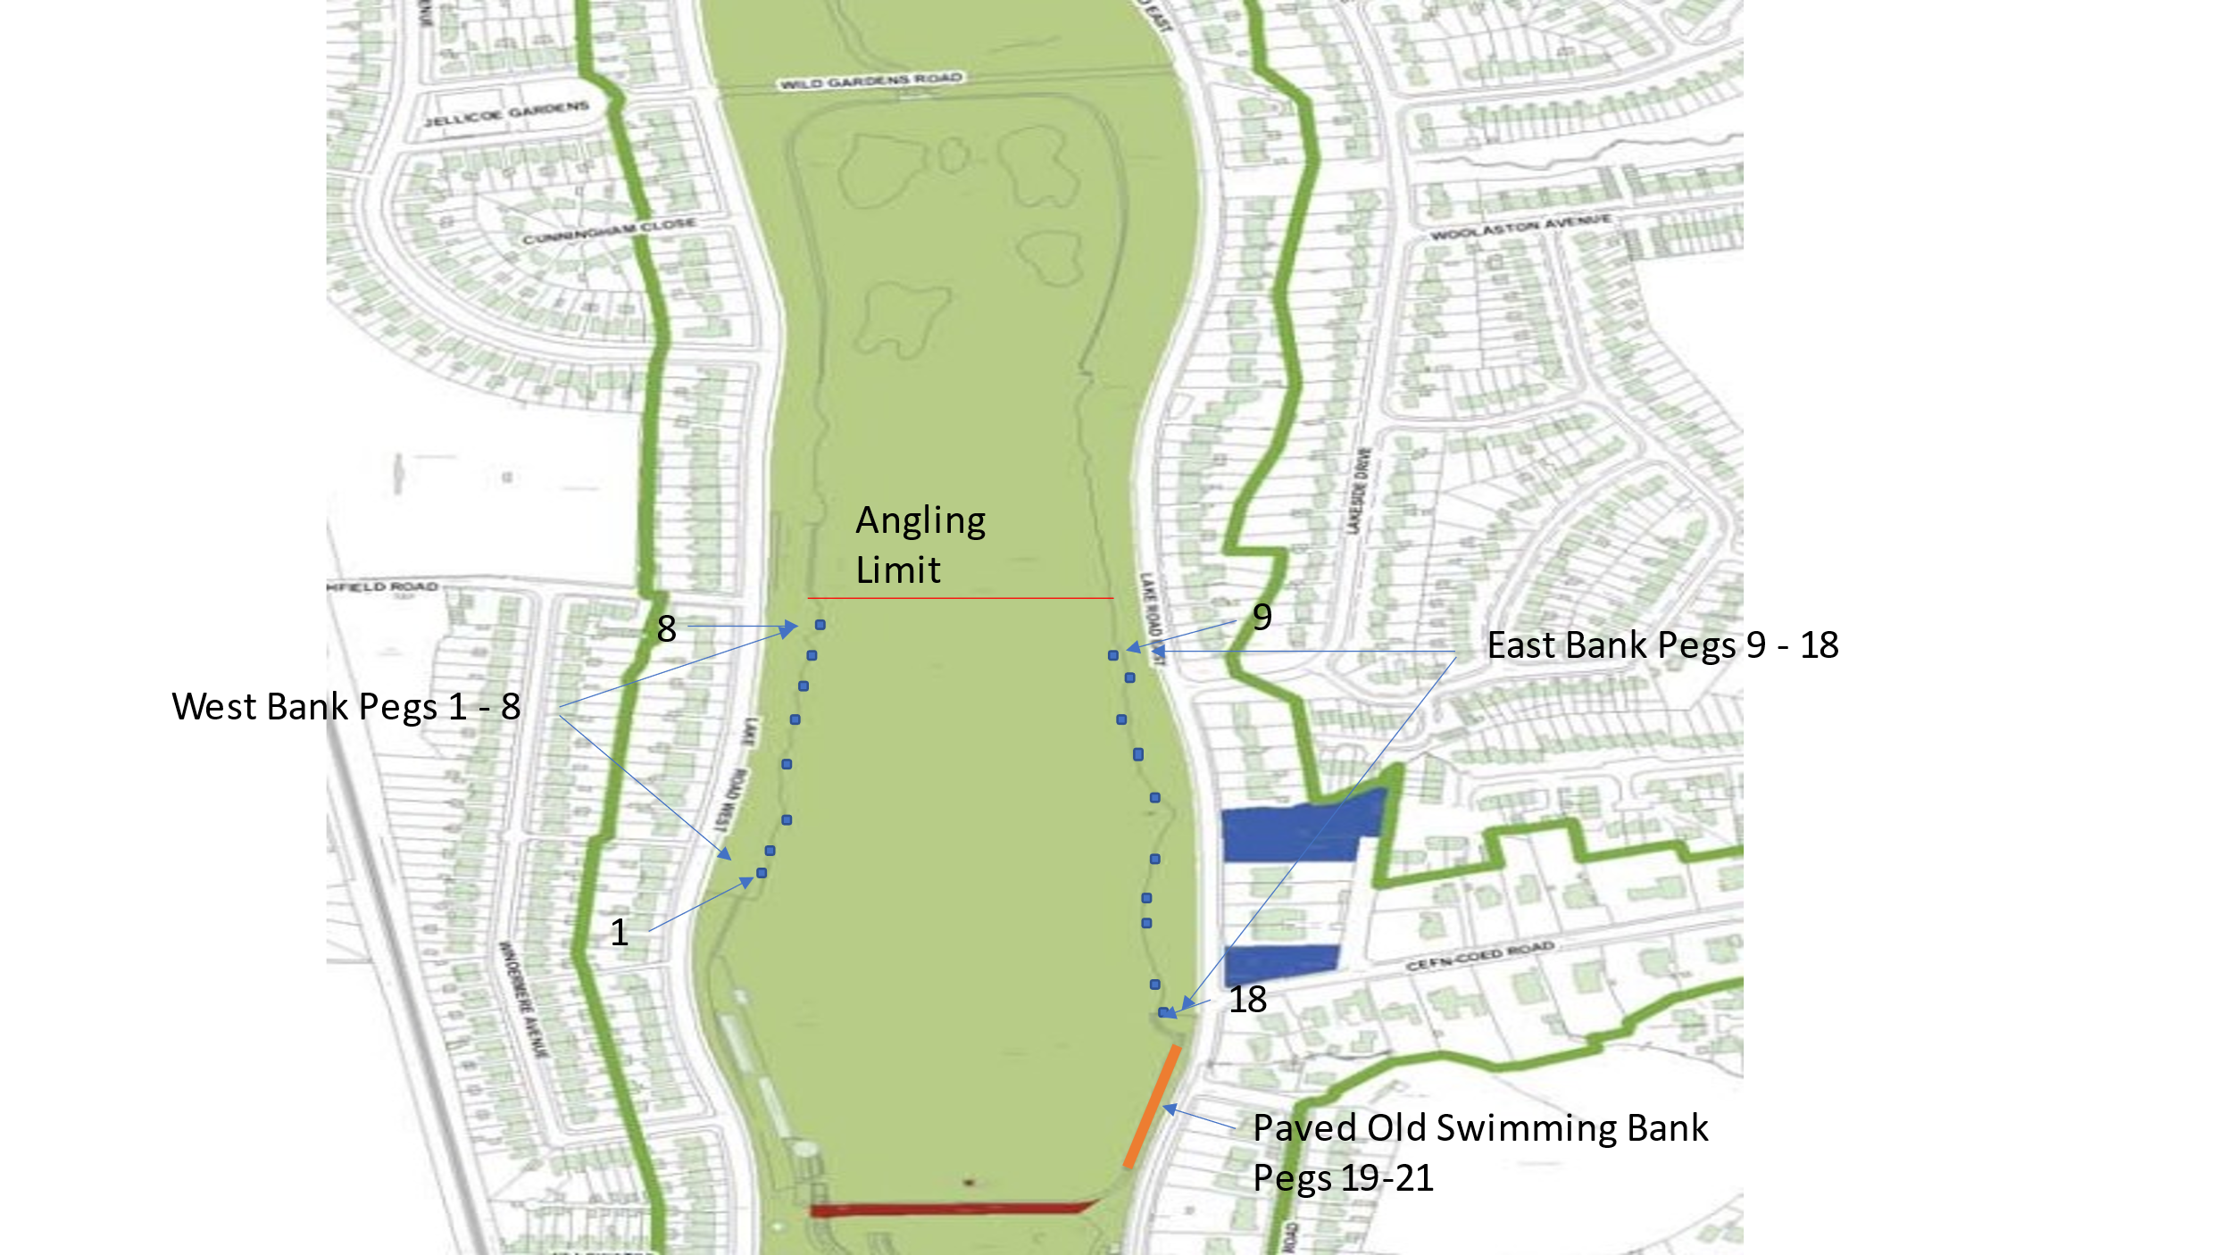

- Only Fishing off Numbered Pegs.
- Night Fishing Pegs 1, 4, 8 11,14,18 – Strictly Night Season Ticket Holders Only.
- Night Sessions are a maximum of 48 consecutive hours. (Dawn-Dusk-Dawn-Dusk.) You must be off the peg before 7am
- Daytime Angling is 7am to Dusk.
- Strictly No Fires or BBQ’s
- Pegs 19 , 20 and 21 are Daytime Fishing Only
- All pegs must be pre booked, Daytime or Overnight Fishing.

RULES FOR FISHING ROATH PARK LAKE

General.
- Only full GAC Members or Roath Park Lake Only card holders are permitted to fish the lake.
- You must pre book your peg before fishing the lake via the Clubmate booking portal.
- Night Fishing is only permitted from designated Night Fishing pegs and must be pre booked.
- Fishing is only permitted from numbered pegs.
- Strictly no surface baits.
- Bolt Rigs are strictly prohibited.
- Barbless hooks only.
- No litter to be left on any peg.
- Carp Sacks are prohibited
- Please respect the residents around the Lake when fishing, keep noise to a minimum especially at night.
- You must present your Membership Card to any Club Bailiff, Club Official, NRW Officer, Cardiff City Council official or Club Member when requested. Failure to do so will mean you will be asked to leave the water and possible expulsion from the Club.
- No guests are permitted to fish with a Club member or Roath Park only member at any time, card holders only. (Only exception is a Junior Member is allowed to fish with a Senior Member on the same peg)
- No dogs allowed
- No fires or BBQ’s
- Fishing is only permitted from the bank.
- Strictly no Fly Fishing.

Carp Fishing.
- No Bolt Rigs
- Barbless hooks only
- No Carp sacks permitted
- Anglers must use a suitable unhooking mat or cradle at all times
- Landing nets must be a minimum of 36 inch
- No surface baits permitted
- All fish must be immediately returned to the Lake.
- Maximum of 2 rods
- Method feeders free running only (no fixed or elasticated.)

Pike Fishing.
- Pike fishing is permitted from 1st October to 31st March.
- Semi barbed treble hooks only.
- Wire traces must be used at all times.
- No Live Baiting
- Landing nets must be a minimum of 36inch
- Unhooking mats or cradles to be used at all times
- Wire Traces to be used at all times for any pike fishing
- Anglers must have the correct unhooking equipment for Pike
- no Gags or Gaffs permitted.
- All Pike must be immediately returned to the Lake

